**Experiment No. 1.2**

**Student Name: Rishav Kumar UID: 22MCC20039**

**Branch: MCA - CCD Section/Group: MCD-1/ Grp A**

**Semester: IV Date of Performance: 19th Jan 24**

**Subject Name: CI/CD Pipelines Subject Code: 22CAP-781**

1. **Aim/Overview of the practical:**

A. Explore Github Workflows.

B. Create a workflow YAML script to build a Maven Project and display output of execution of all the 09 goals of maven.

1. **Code for practical:**

**A)**

Gitflow is a legacy Git workflow that was originally a disruptive and novel strategy for managing Git branches. Gitflow has fallen in popularity in favor of trunk-based workflows, which are now considered best practices for modern continuous software development and DevOps practices. Gitflow also can be challenging to use with CI/CD. This post details Gitflow for historical purposes.

**B)**

* Create a repository and publish on github.
* Click on Actions and click on create workflow file.
* You can choose pre-built templates from it for maven with JAVA.
* In workflow.yml file add following script.

name: Java CI with Maven

on:

  push:

    branches:

      - master

  pull_request:

    branches:

      - master

jobs:

  build:

    runs-on: ubuntu-latest

    steps:

    - name: Checkout repository

      uses: actions/checkout@v2

    - name: Set up JDK

      uses: actions/setup-java@v2

      with:

        distribution: 'adopt'

        java-version: '11'

    - name: Clean

      run: mvn clean

    - name: Validate

      run: mvn validate

    - name: Compile

      run: mvn compile

    - name: Test Compile

      run: mvn test-compile

    - name: Package

      run: mvn package

    - name: Verify

      run: mvn verify

    - name: Install

      run: mvn install

    - name: Build Docker image

      run: docker build -t yourusername/yourappname:${{ github.sha }} .

    - name: Log in to Docker Hub

      uses: docker/login-action@v1

      with:

        username: ${{ secrets.DOCKERHUB_USERNAME }}

        password: ${{ secrets.DOCKERHUB_PASSWORD }}

    - name: Push Docker image

      uses: docker/build-push-action@v5

      with:

          push: true

          tags: ${{ secrets.DOCKERHUB_USERNAME }}/app:latest

* It will perform actions when any pull or push will be reflected to repository.

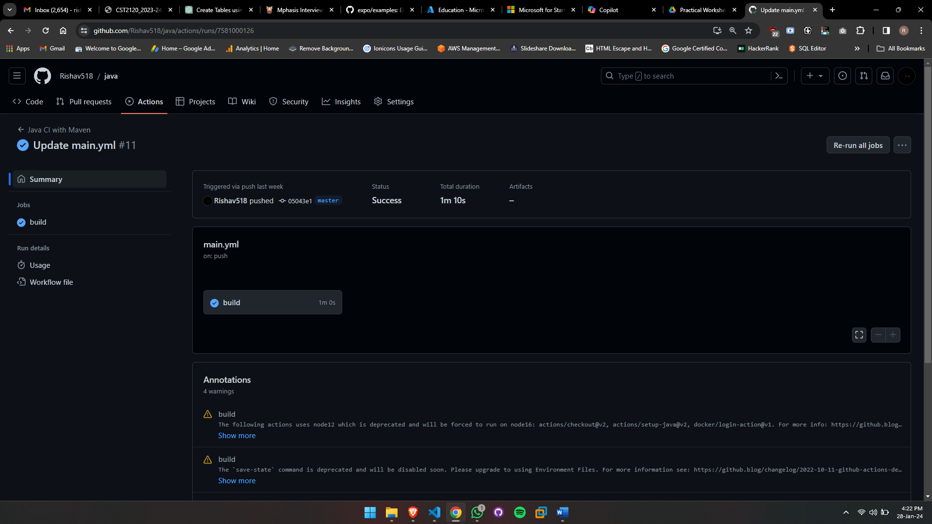

* After completing all goals of maven, it will automatically make an image an push to DockerHub.

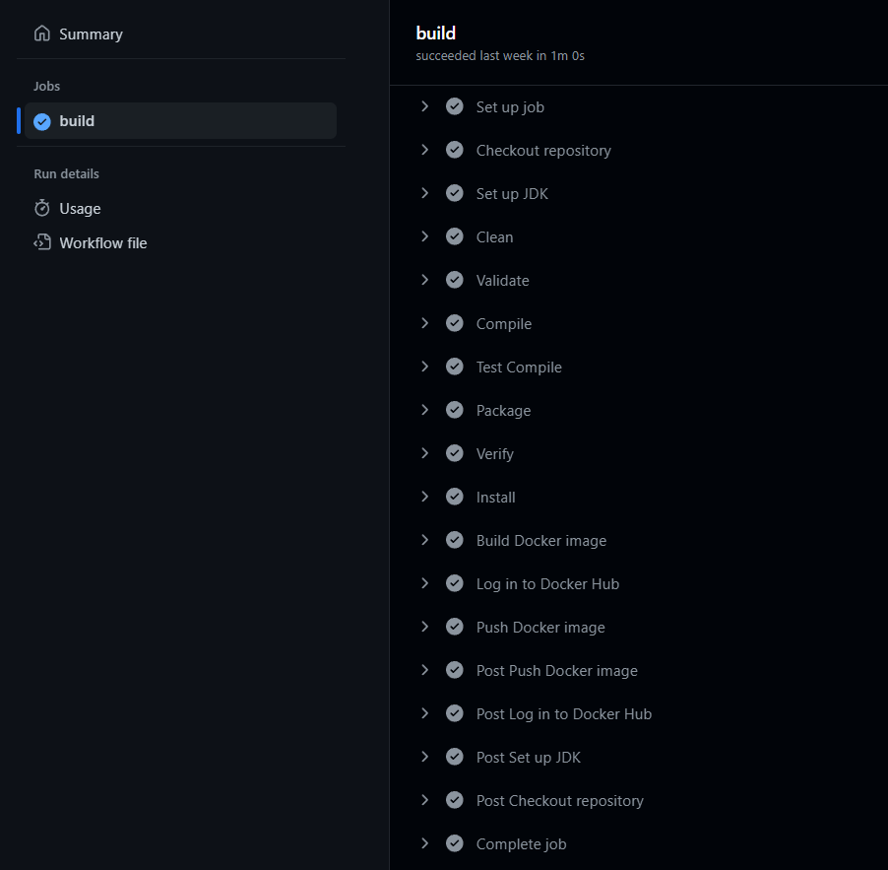

**************************************** **THE END** ***********************************************